Modelling of Dependence of Mechanical Properties of Cast Iron on Chemical Composition of Raw Materials

Olena Tokova
Yevgeniya Savchenko

Department for Information Technologies of Inductive Modelling
International Research and Training Centre for Information Technologies and Systems
of the NAS and MES of Ukraine, Kyiv, 03187, Ukraine

len327@ukr.net
savchenko_e@meta.ua

Abstract — The problem of the influence of the chemical composition of pig iron on its mechanical properties, such as ultimate tensile strength, elongation, impact test and hardness by Brinell solved. Based on the combinatorial GMDH algorithm, linear and nonlinear models of dependence of the mass fraction of components of raw materials on each of the indicators describing the quality of the casting are constructed. The obtained models allow us to analyze how changes in the mass fraction of each of the components affect each of the variables of mechanical properties.
Keywords—casting, ultimate tensile strength, elongation, impact test and hardness by Brinell, ductile iron, mechanical properties, cast iron, chemical composition, modeling, GMDH.

Introduction
Cast iron is one of the most commonly used materials in many industries in various industries. This material has good founding qualities, such as fusibility, durability, ductility and in many cases is used at high loads instead of steel castings. The advantages of ductile iron compared to steel are relatively low melting point, and therefore lower energy consumption on the melt, better liquidity and filling of molds, the ability to cast structural and complex parts, etc. From the ductile iron, a large number of castings of various applications are made due to the fact that the ductile iron properties can be changed within a wide range of regulated chemical composition, doping, heat treatment and other methods.
The purpose of this work is to build models of dependence of the mechanical properties of cast iron on its chemical composition and, on their basis, analyzing cast components and how each of the components affect on each of the variables of mechanical properties. The use the information systems allows you to manage the process and constantly monitor the indicators of input and output of each operation of the process, compare them with the given, and, if necessary, make adjustments to the current production.
Authors developing a technology that would make it possible to verify the quality of future goods through modeling of mechanical properties of cast iron on its chemical composition.

An Overview of Methods for Studying the Dependence of the Mechanical Properties of Ductile Iron on its Chemical Composition
The melt metal is a complex solution, which may contain a number of unsuitable elements for the production of ductile grey iron. The molten cast iron contains areas enriched with carbon, higher amount of silicon in local areas, manganese, sulphur and phosphorus. These elements can adversely affect the properties of the produced iron for the automotive industry. The oxygen activity, hardness, tensile strength, viscosity, chemical composition, and other physical and mechanical properties of cast iron are studied in [1].
The study [2] analyses how the chemical composition influences the mechanical properties of grey cast iron. The influence of chemical compositions on the mechanical properties of Si-Mn-Mo low carbon bainitic steel was analyzed in [3] and the empirical formulas expressing the relationship of chemical compositions and the mechanical properties at various cooling rates was established based on a large amount of experiments. The effect of silicon in the steel was studied. The results show that, the strength and Charpy impact work of the steel increase first and decrease afterward as the silicon content increases and both of the strength and Charpy impact work reach the maximum simultaneously under certain silicon content.
Metallurgical systems include a set of various physical and chemical transformations, the final stage of which is the production of metallic materials with desired properties. Such systems are quite complex. As subsystems, they include such elementary processes as chemical processes, phase transformations, heat and mass transfer, mechanical phenomena, etc.
Understanding and controlling the graphite expansion during the eutectic solidification of cast iron is of vital practical importance, as graphite expansion directly affects the shrinkage propensity. Numerous studies have been conducted to measure the amount of this expansion and the time of its occurrence. In paper [4], a Liquid-to-Solid Dilatometer, which almost eliminates the mold displacement, is introduced. It allows concomitant recording of the cooling curves and of the linear displacement that occurs during solidification. This makes possible a combined interpretation, giving an unambiguous answer to questions such as the beginning and end of the eutectic solidification. Experimental results for gray, ductile and compacted graphite cast iron are presented in [4] and the effect of chemical composition on graphite expansion is analyzed.
Experiments in [5] are made on 16MnREL steel plate with different contents of carbon, manganese and silicon under controlled rolling and controlled cooling conditions. The influences of chemical composition and technological parameters of controlled rolling and controlled cooling on the microstructure and mechanical properties as well as broad cold bending property of the steel plates are studied.
The aim of the study [6] is to investigate the relations between the thermal analysis parameters and the graphite morphologies of the cast irons that were produced over a suitable range of Mg/S ratios and to attempt to present a methodology that can supply information during production.
The technique is based on characteristic temperatures on the cooling curve. Production of compacted graphite iron is not a straight forward process due to its narrow processing parameters. Therefore, application of an online quality control tool by means of thermal analysis becomes an essential and important tool for this process [6].
In [7] developed a quantitative and non-destructive on-line process control method which can be used in different aspects of aluminium cast alloys. In this method, the temperature changes in the sample are recorded from fully liquid to fully solidiﬁed phase producing a curve plot of temperature as function of time. A cooling curve reﬂects the release o latent heat of solidiﬁcation. This release of latent heat in multi-component alloys changes the slope of the cooling curve which is then used to detect the characteristics of transformations and phase reactions during solidiﬁcation.

The Task of Modeling the Dependence of Mechanical Properties on the Castings Chemical Composition
The choice of brand of ductile iron for the manufacture of parts is carried out in line with requirements for its physical, mechanical and operational properties, which are determined by their chemical composition and structure.
The main indicators characterizing the quality of charge materials are: the chemical composition and its stability, the content of elements of impurities, the degree of contamination of the composition of the charge with oxides, harmful impurities and non-metallic inclusions.
To obtain the necessary mechanical properties of the ductile iron must have the necessary and controlled chemical composition and structure. In addition to the usual elements that are part of gray iron (carbon, silicon, manganese, phosphorus, sulfur), the production of high-strength cast iron controls the residual content of modifying elements and periodically check charge materials for chromium and demodifying elements.
Carbon in malleable iron may be in the form of graphite. Low carbon content is not recommended, since it has been proven by practice that the highest mechanical properties of a casting manifest themselves with its high content, then cast iron has the best casting properties. Silicon provides a graphitize effect. When the silicon content is more than 3.0%, cast iron significantly loses plasticity. Manganese also significantly reduces the plastic properties of cast iron.
To assess the quality of cast iron, the most common are ultimate tensile strength, elongation, impact test and hardness by Brinell. These indicators relate to the mechanical properties of metals and alloys.
The purpose of the example is the application of the combinatorial algorithm of GMDH for constructing models of dependence of the chemical composition on the mechanical properties of the raw materials. For each output variable it is needed to find a dependence on the form 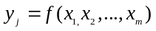, m – number of variables of data sample, j – index of input variables, 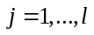.

Experimental Data of Physics and Technology Institute of Metals and Alloys
Experiments were conducted at the Physics and Technology Institute of Metals and Alloys (PTIMA) of the National Academy of Sciences of Ukraine to determine the influence of chemical composition on the mechanical properties of ductile iron [8]. Experiments make it possible to determine which chemical composition of the ductile iron should be in order to obtain the optimal combination of ultimate tensile strength, elongation, impact test and hardness by Brinell of cast iron.
In the course of experiments, data were obtained that characterize the factors affecting the mechanical properties of the ductile iron. These indicators characterize the quality of the finished casting. Data sample contains 22 observations for five input and 4 outputs variables. As input parameters, the mass fraction of each component of raw material for the formation of castings as a percentage of the total mass is taken (Table I): – carbon (C), – silicon (Si), – manganese (Mn), – chromium (Cr), – phosphorus (P). The mechanical properties are described by the following output variables: is the ultimate tensil strength 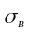, MPa, 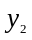 – elongation, %, 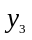 – impact test К_{С,} J/cm², 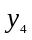 – hardness by Brinell НВ, kgF/mm².
Since the orders of magnitude of data values are very different, all the variables listed in the table are scaled, that is, each one is divided by the maximum value for a variable.
The last three observations were left for the exam (C), that is, to test the model for data that was not used when constructing the model. For each of the output variables, a model is constructed on the basis of the combinatorial GMDH algorithm with the after-determination of the model [11].

- Fragment of Input Data
№
№ | С | Si | Mn | Cr | P | ,  MPa | , % | К_{С},  J/cm² | НВ, kgF/mm²
1 | 3.39 | 2.31 | 0.33 | 0.065 | 0.04 | 597 | 5.4 | 9 | 229
2 | 3.48 | 2.65 | 0.33 | 0.065 | 0.04 | 567 | 19.3 | 106 | 197
3 | 3.42 | 2.83 | 0.33 | 0.065 | 0.04 | 537 | 10 | 29 | 207
… | … | … | … | … | … | … | … | … | …
20 | 3.34 | 2.66 | 0.52 | 0.1 | 0.18 | 598 | 14 | 25 | 170
21 | 3.4 | 2.9 | 0.52 | 0.1 | 0.25 | 624 | 15 | 18 | 170
22 | 3.28 | 2.83 | 0.52 | 0.1 | 0.35 | 624 | 12 | 2 | 170

Models Construction of Dependence of Mechanical Properties From Chemical Composition

Combinatorial GMDH algorithm with after-determination of models
The method of after-determination of model choice is described [11], which enables to find an optimum model in the case of ambiguousness of choice of model by only one criterion (regularity).
To calculate the regularity criterion, the data sample W is ranked by variance and divided into training A, testing B and examination C subsamples, , 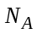, 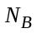, 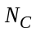 – number of points of the subsample A, B, C respectively.
The calculation of the regularity criterion is carried out according to the formula:
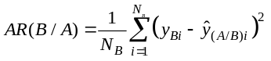, (1)
where 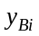 is the actual values of the output in the data sample on the test subsample B; 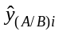 – output values on the test subsample B, calculated by the model, the coefficients of which are obtained on the training subsample A.
For after-determination the value of bias criterion is calculated which is more sensible to the change of model complexity than the known solution bias criterion.
Calculation of the bias criterion:
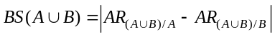, (2)
where 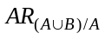 and 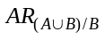 is a total errors on the sample of a model of the same structure with the parameters estimated on subsamples A and B respectively.
Accuracy of the obtained model is checked on the subsample C:
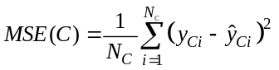. (3)

Construction a linear model
Table II shows the modelling results for linear models 1 – 4 constructed by the described algorithm.
- Constructed Linear Models
№ | Model | 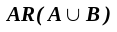 | 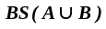 | 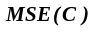
1 | 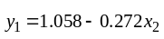 | 0.00457 | 0.00156 | 0.00567
2 | 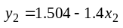 | 0.05699 | 0.04099 | 0.01898
3 | 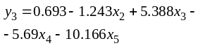 | 0.15741 | 0.04251 | 0.02037
4 | 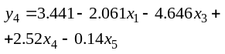 | 0.00514 | 0.02802 | 0.00407

Construction of non-linear models
To increase the accuracy of the modeling, the squares of the input variables were added to the input sample, thus the sample contained 10 variables (added variables in what follows are 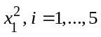). Similarly, using the combinatorial GMDH algorithm with the after-determination of model by bias criterion, the models 5 – 8 were constructed (Tab. III).
- Constructed Nonlinear Models
№ | Model | 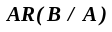
5 | 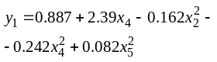 | 0.00383 | 0.00904 | 0.00417
6 | 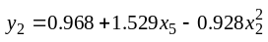 | 0.05629 | 0.07598 | 0.01983
7 | 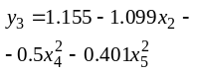 | 0.14555 | 0.05418 | 0.01055
8 | 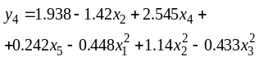 | 0.00366 | 0.0073 | 0.00023
Fig.1 to 4 show the graphs of the dependence of real data and obtained by linear and nonlinear models.
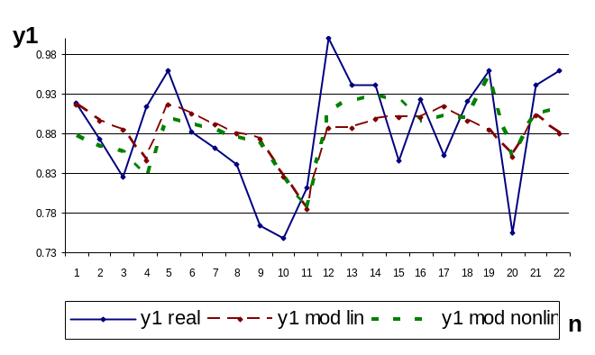
- The real values of y₁ and calculated by linear and nonlinear models
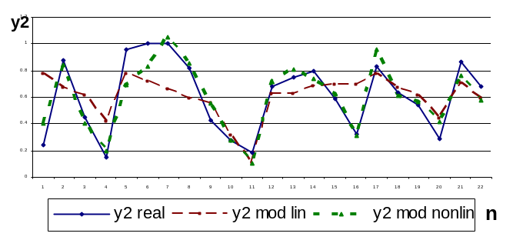
- The real values of y₂ and calculated by linear and nonlinear models
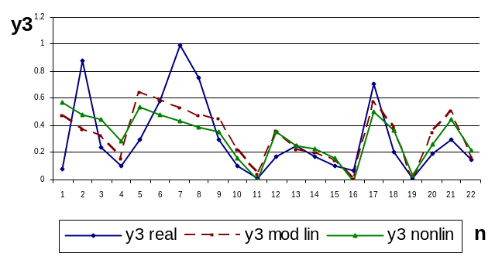
- The real values of y₃ and calculated by linear and nonlinear models
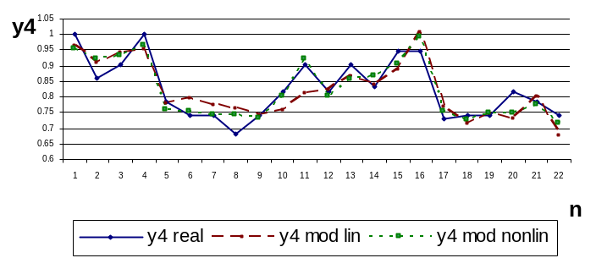
- The real values of y₄ and calculated by linear and nonlinear models
From the comparison of the modelling results (Tables I and II), it can be said that nonlinear models have slightly smaller criterion values 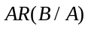. The value of 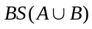 criterion for the three models is best for nonlinear models, but this is an additional criterion. The 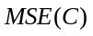 exam subsample score also shows the advantage of non-linear models.
Conclusion
Models have been constructed that describe the dependence of mechanical properties from the chemical composition of raw materials. The accuracy of the obtained nonlinear models is better than the precision of the linear ones, and it is precisely such models that are better to use in modeling the dependence of mechanical properties on the chemical composition.
The analysis of the obtained nonlinear models shows that the increase in the tensile strength slightly affects the increase in the content of chromium and the reduction of silicon. An increase in the relative lengthening is influenced by an increase in the proportion of phosphorus and a decrease in silicon model 6. The increase in impact strength is achieved by reducing the content of silicon, chromium and phosphorus model 7. Increase in hardness is achieved by reducing the proportion of silicon, carbon and magnesium model 8.
The generalization of the obtained results shows that the greatest influence on the result is the magnitude of the mass fraction of silicon: its reduction in the alloy increases the magnitude of the strength limit and relative elongation. The increase in impact resistance is achieved by reducing the proportion of chromium and phosphorus. Increase in hardness is achieved by reducing the proportion of carbon.
References
- J. Machuta and I. Nová “Metallurgy of the Grey Cast Iron for the Automotive Part” https://www.researchgate.net/publication/ 32171
0911_Metallurgy_of_the_Grey_Cast_Iron_for_the_Automotive_ Parts
- L. Álvarez, C.J. Luis and I. Puertas, “Analysis of the influence of chemical composition on the mechanical and metallurgical properties of engine cylinder blocks in grey cast iron” https://www.infona.pl/resour
ce/bwmeta1.element.elsevier-5690f7c8-a9e0-3c19-87d3-244e57fef594
- M. Zhang, M. Kang and L. Zhou, “Relationship of chemical composition and mechanical properties of Si-Mn-Mo low carbon bainitic steel” https://www.researchgate.net/publication/287373623
Relationship_ of_chemical_composition_and_mechanical properties_
of_Si-Mn-Mo_low_carbon_bainitic_steel
- Doru M. Stefanescu, M. Moran, Sarum Boonmee, Wilson Guesser “The Use of Combined Liquid Displacement and Cooling Curve Analysis in the Understanding of the Solidification of Cast Iron” https://www.researchgate.net/publication/260060066_The_Use_of_Combined_Liquid_Displacement_and_Cooling_Curve_Analysis_in_Understanding_the_Solidification_of_Cast_Iron
- Ch. Sun, “Influences of chemical composition and technological parameters of controlled rolling and controlled cooling on mechanical properties of 16MnREL steel plate” https://www.researchgate.net
/publication/291473833_Influences_of_chemical_composition_and_technological_parameters_of_controlled_rolling_and_controlled_cooling_on_mechanical_properties_of_16MnREL_steel_plate
- Omar Elmabrouk, Arda Çetin, Ali Kalkanli, Ekrem Selcuk “Application of cooling curve analysis as a process control tool to produce compacted graphite cast iron” https://www.researchgate.net/publication/
249922242_Application_of_cooling_curve_analysis_as_a_process_control_tool_to_produce_compacted_graphite_cast_iron .
- Saeed Farahany, Ali Ourdjini, Mohd Hasbullah Idris, “Computer-aided cooling curve thermal analysis of near eutectic Al–Si–Cu–Fe alloy” https://www.researchgate.net/publication/263608102_Computer-aided
cooling_curve_thermal_analysis_of_near_eutectic_Al-Si-Cu-Fe_alloy.
- B.H. Zelenyi, O.O. Yasynskyi, V.B.Bublykov and L.A. Zelenaya, “The influence of batch materials, modifying modes on the structure and properties of high-strength cast iron” Materials IX of the International Scientific and Practical Conference, May 21-24, 2013, Zaporizhia. ZTPP. pp. 68-73 (In Russian).
- O. Tokova and Ye. Savchenko, “Inductive Modelling as a Basis of Informational Support of Decisions in Casting Production”. Proceedings of the XII IEEE International Conference CSIT-2017 & International Workshop on Inductive Modeling, Sept. 5-8, 2017, Ukraine, Lviv: Publisher “Vezha&Co”, 2017, pp. 507-510.
- Yе. Savchenko, V. Stepashko and O. Tokova, “A new method of comparing cooling curves to recognize the casting quality”, Proceedings of the IEEE 13th International Scientific and Technical Conference on Computer Sciences and Information Technologies, CSIT 2018. Sept. 11-14, 2018, Ukraine, Lviv: Publisher “Vezha&Co”, 2018, pp. 457-460.
- A.G. Ivakhnenko and E.A. Savchenko, “Investigation of Efficiency of Additional Determination Method of the Model Selection in the Modeling Problems by Application of GMDH Algorithm”, Journal of Automation and Information sciences. Begell House. Inc. Publishers. 40, N 3, 2008, pp. 47-58.

